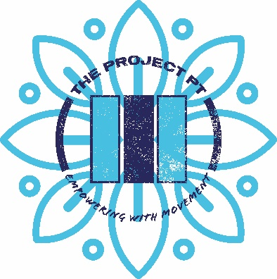
The Project PT Limited
Coach/Personal Trainer

Working hours:
35hrs
Salary: £21-25k
Monday-Sunday 6am-9.30pm
(Rota’d hours.) Rotas are sent out by management one month in advance.
Movement Coach Duties:
- Coaching clients through sessions, Strength, Hybrid, Cardio, Kettlebells, Core & Mobility, Powerlifting.
- Creating training programs for clients alongside the lead coach.
- Helping in the smooth running of training sessions for members.
- Maintaining a clean and tidy gym.
- Opening and locking up the gym.
- Completing health and safety tasks to ensure the gym adheres to their health and safety policy.
- Responding to member communication.
- Marketing the studio through leafleting and canvassing.
- Creating informational material, blogs, social media posts.
- Coaching 1:1 sessions within people’s homes.
Full training for all of the above duties and tasks will be given.
Team members are given 3 monthly appraisals to help with their career progression.
Name:

Date:

Signature:

